1. Installing Quandl, so that we could fetch stock data from quandl website.

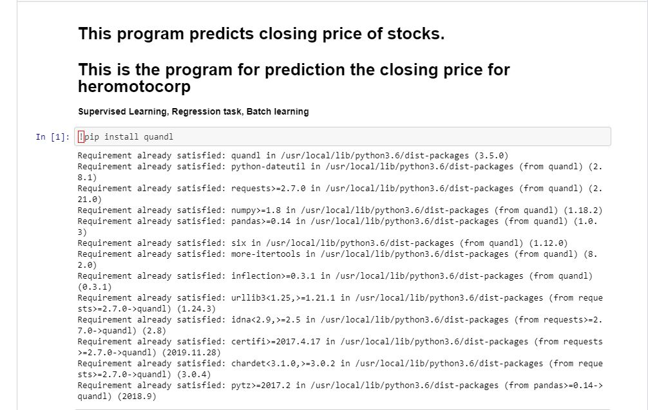

2. Importing Libraries

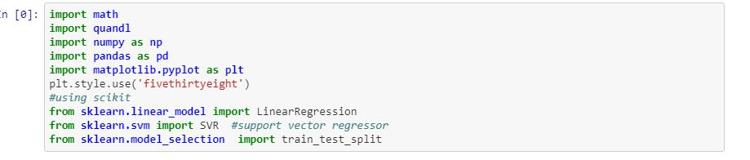

3. Getting stock data of HeroMotoCorp. From BSE/Quandl database. You can put any stock of your choice here for analysis.

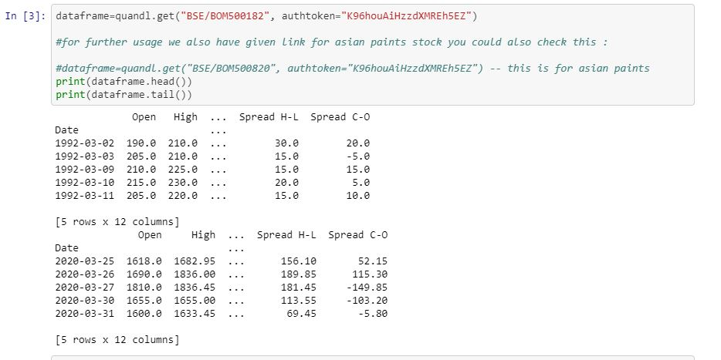

4. Getting information about the dataset we got:

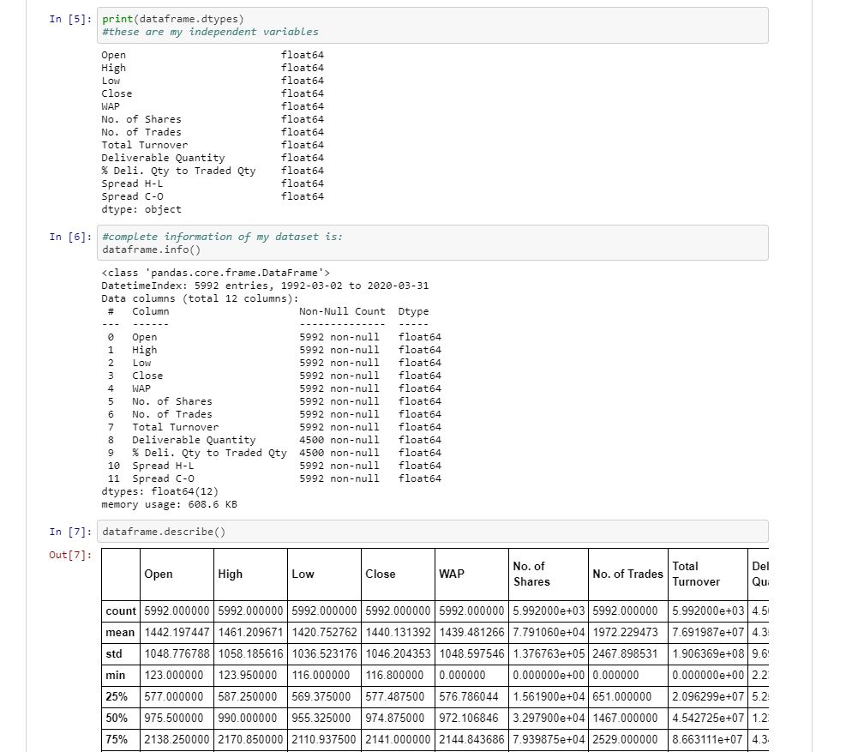

6. Visualizing our dataset:

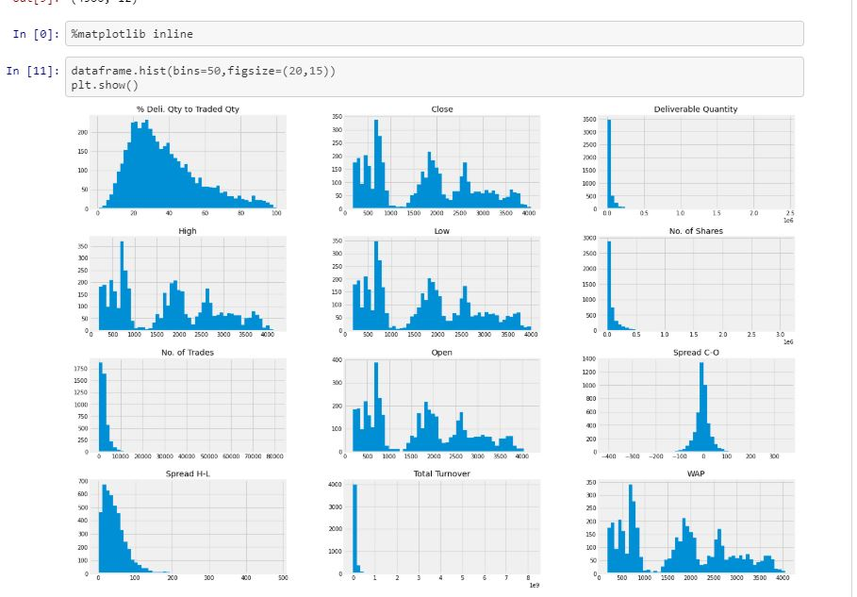

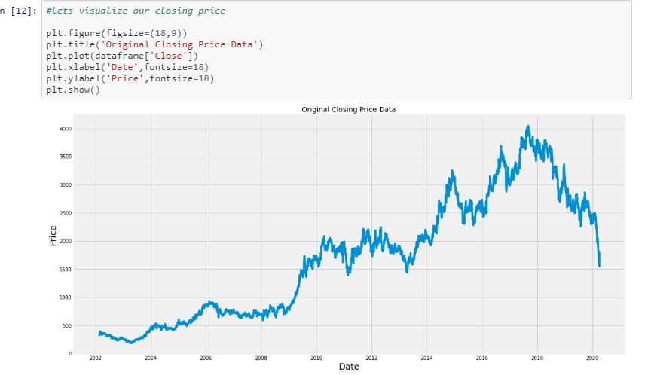

7. Getting the input() for the number of days u want to predict the stock closing price.

And setting our data set for Predictions.

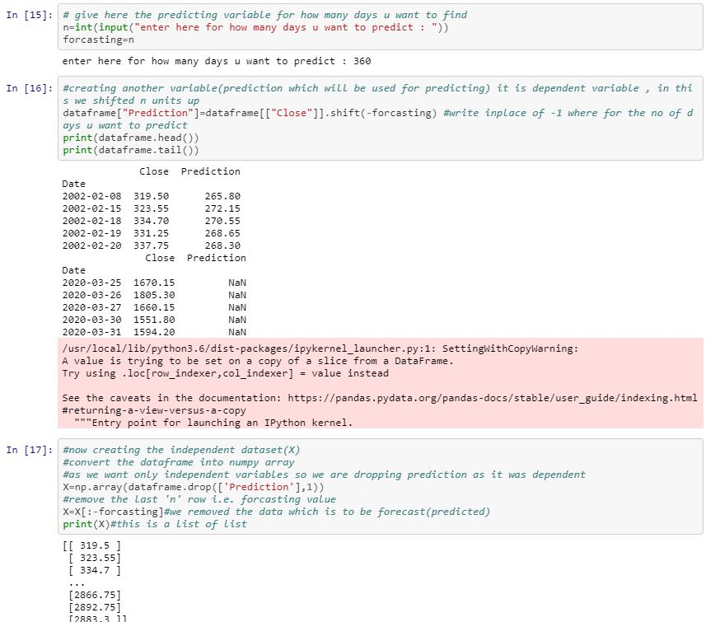

8. train_test_split() function used from scikit

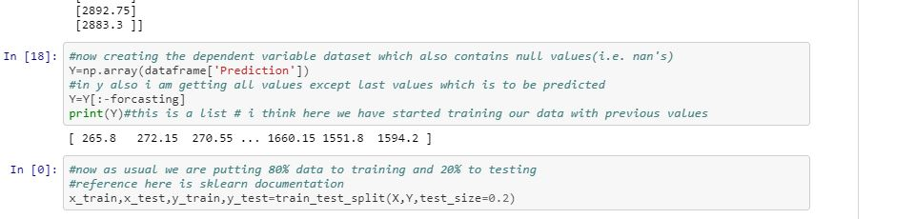

9. Training our model

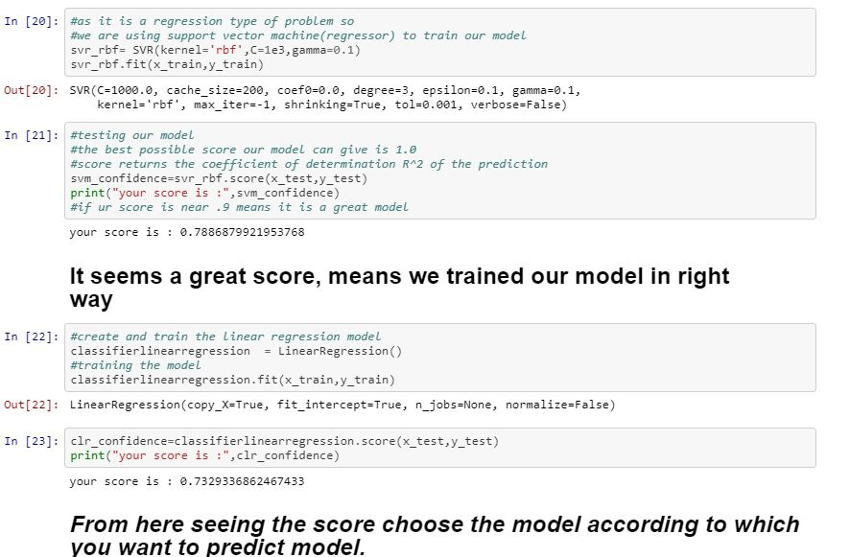

10. Original closing prices dataset

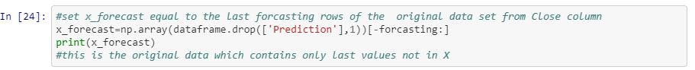

11. Predicted values by Linear Regression after training.

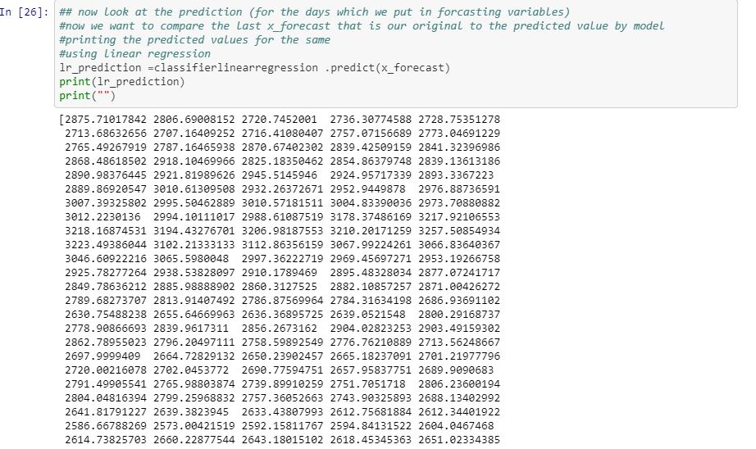

12. Visualizing our Predicted data vs Original data Results:

A. for SVM

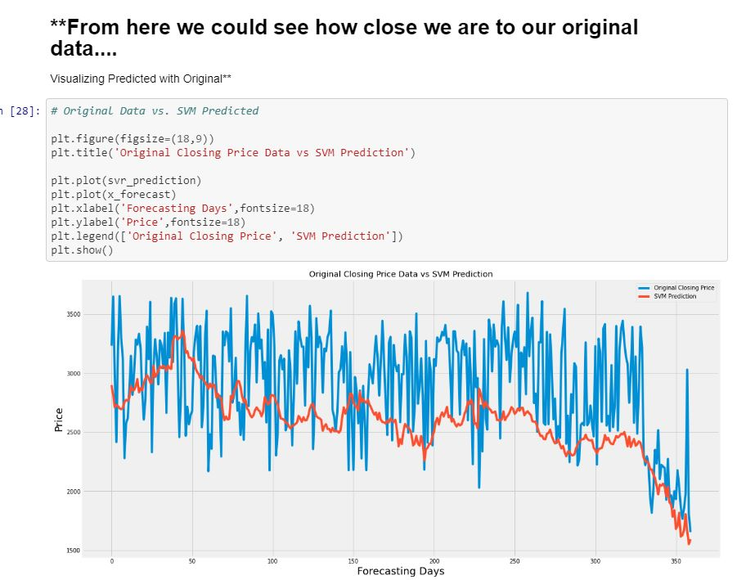

B. From Linear Regression WE got amazing results:

